1. Introduction

Cognitive systems are related to an organism’s (preferably human) observable behavior. Human cognition has not yet been understood completely and we are still in the process of unlocking the infinite amount of mysteries hidden in human cognition. Various researchers throughout the world are taking different approaches to collect as much information as possible and conducting experiments in order to unmask the unknown universe of our mysterious brain. We are really very concerned about human cognitive decline. Cognitive decline is the deterioration in our valuable cognitive function. There is a normal process of age related cognitive decline across the life span characterized by increasing difficulties with memory (new learning), information processing speed, language and other cognitive functions.

 A large number of studies, some even in very high impact journals, are suggesting that regular video game players have demonstrated a number of cognitive benefits relative to non-video game players. These include improved eye-hand coordination, visual attention, spatial abilities, visual acuity, and ability to simultaneously track multiple moving visual items etc.

In this research I have developed some games in iOS device, which will help enhance human cognition. Brain performance has been calculated by brain performance index. People from all age groups can be benefited in their cognitive skills by regularly exercising these games.

1. Definition and classification of Cognitive Abilities

We can take this as the definition of human cognitive abilities – “Cognitive abilities are the brain-based skills and mental processes needed to carry out any task and have more to do with the mechanisms of how we learn, remember and pay attention rather than any actual knowledge we have learned.”

Here is a description of key cognitive skills that are critical for learning.

1. **Memory:**

The ability to store and recall information. The conscious recall of the source and circumstances of a specific memory is defined as contextual memory. Such recall may include time, place, people, emotion or any other contextual information related to a memory event. In figure 1, we can see the memory formation cycle.

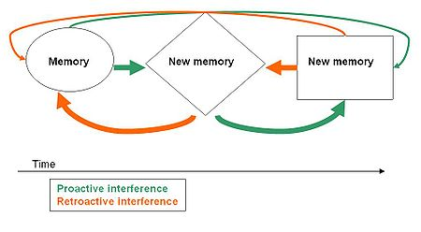

Figure 1: Memory formation cycle

Partial or erroneous encoding of the contextual details of an event while it happens may occur due to time constraints, high levels of stress, distractions or poor information processing skills. We can classify memory into two types. They are as follows:

1. 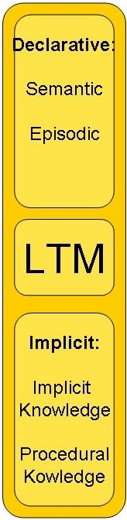**Long-Term Memory (LTM):** Long-term memory is the capacity to maintain information as little as a few days or as long as decades. Long-term memory is critical for spelling, recalling facts on tests, and comprehension. Weak long-term memory skills create symptoms like forgetting names and phone numbers, and doing poorly on unit tests. For example, you notice a face on the newspaper and you realize that you saw that person before. You think about it and remember that you saw him on a shiny morning while running in the park and felt little bit weird about him at that moment. However, long-term memory is closely related to short-term through the process of rehearsal and meaningful association.

Figure2: Long Term Memory

1. **Short-Term/Working Memory (STM):** The ability to apprehend and hold information in immediate awareness while simultaneously performing a mental operation. Students with short-term memory problems may need to look several times at something before copying, have problems following multi-step instructions, or need to have information repeated often. There is again visual, sensory and auditory short-time memory. Visual short-time memory is connected with the information we can hold that we have just seen whereas sensory memory is related with our senses.

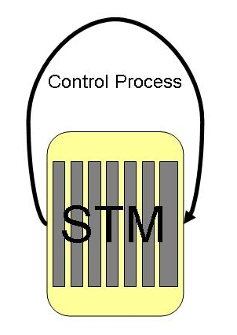

Figure 3: Short Term Memory

Auditory short-time memory is the ability to remember auditory information over a brief period of time (in the order of seconds). Auditory memory is thought to last a little longer than visual and sensory memory. For example, you went to a party and the host introduced his friends to you whom you didn’t know before. Later you turn to one of them trying to recall his or her name and start a conversation.

1. **Attention Skills:**

A student’s ability to attend to incoming information. It can be observed, broken down into a variety of sub-skills, and improved through properly coordinated training.

There are three primary types of attention:

1. **Selective Attention:**The ability to remain focused and on task while being

subjected to related and unrelated sensory input (distractions).

1. **Divided Attention:**The ability to remember information while performing a mental operation and attending to two things at once (multi-tasking).
2. **Sustained Attention:**The ability to remain focused and on task, and the amount of time we can focus.

***Response Time*** is also included in human attention skills. Response time is the ability to perceive and process a simple stimulus and respond to it. All actions are affected by our processing speed. Longer response time means poorer execution of various actions. For example, when driving, we may suddenly find something potentially dangerous and immediately step on the brakes to avoid it.

***Shifting*** is a mental process during which people redirect their focused attention from one channel of information to another as quickly as possible or change the course of their actions while maintaining accurate performance. We can initiate brain shifting consciously or unconsciously .It can be done by a stimulus in our surroundings or by habit.　For example, while talking on the phone, we may have to switch to preventing a small grandchild from touching a sharp object. Many older people encounter shifting problems; they may find it difficult and frustrating to try to change their thinking, routines or actions.

1. **Logic and Reasoning:**

The ability by which we reason, form our concepts, and solve problems using unfamiliar information or novel procedures. Deductive reasoning extends this problem solving ability to draw conclusions and come up with solutions by analyzing the relationships between given conditions. Students with underdeveloped logic and reasoning skills will generally struggle with word math problems and other abstract learning challenges.

1. **Spatial and Visual Perception:**

Spatial Perception is the ability to evaluate how things are arranged in space, and investigate their relations in the environment. We can grasp to arrange our surroundings by good spatial perception. When going to a new place for the first time, we must perceive the layout of the place and comprehend the position of various things. On the other hand, visual perception is the ability to interpret information from the effects of visible light reaching the eye. The resulting perception is known as eyesight, sight or vision. We see images as a whole rather than in parts. However, images can be broken down into their visual elements: line, shape, color, and texture. These elements are to images as grammar is to language. Together these elements allow our eyes to see full images and our brain to recognize them. Students who have problems with visual processing may have difficulty following instructions, reading maps, doing word math problems, and comprehending. Again visual scanning is the ability to actively find relevant information in our surroundings quickly and efficiently. Examples of visual scanning are spotting a certain restaurant in an area full of restaurants.

1. **Auditory Processing:**

The ability to analyze, blend, and segment sounds. Auditory processing is a crucial underlying skill for reading and spelling success, and is the number one skill needed for learning to read. Weakness in any of the auditory processing skills will greatly hinder learning to read, reading fluency, and comprehension.

1. **Speed:**

This refers to the quickness of an individual’s performance in simple or complex cognitive tasks. Information processing speed that is required to have general understanding of that information and further process it is often termed as speed in short. This skill also measures the ability of the brain to work quickly and accurately while ignoring distracting stimuli. Any task may turn to seem difficult without sufficient speed. Slow processing is one root of ADHD-type behaviors. Symptoms of weaknesses here include homework taking a long time, always being the last one to get his or her shoes on, or being slow at completing even simple tasks.

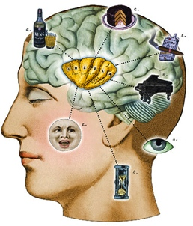

Figure 4:Speedy mind

***Speed Estimation*** is the capacity to estimate an object’s future location based on its current speed. This ability allows you to function in the environment and avoid various moving obstacles around you.

1. **Other Cognitive Skills:** There are whole ranges of cognitive skills that have interrelations with each other and also depend on the abilities mentioned above.

* **Category Flexibility** — The ability to generate or use different sets of rules for combining or grouping things in different ways.
* **Flexibility of Closure** — The ability to identify or detect a known pattern (a figure, object, word, or sound) that is hidden in other distracting material.
* **Fluency of Ideas** — The ability to come up with a number of ideas about a topic (the number of ideas is important, not their quality, correctness, or creativity).
* **Information Ordering** — The ability to arrange things or actions in a certain order or pattern according to a specific rule or set of rules (e.g., patterns of numbers, letters, words, pictures, mathematical operations).
* **Mathematical Reasoning** — The ability to choose the right mathematical methods or formulas to solve a problem.
* **Number Facility** — The ability to add, subtract, multiply, or divide quickly and correctly.
* **Oral Expression** — The ability to communicate information and ideas in speaking so others will understand.
* **Originality** — The ability to come up with unusual or clever ideas about a given topic or situation, or to develop creative ways to solve a problem.
* **Problem Sensitivity** — The ability to tell when something is wrong or is likely to go wrong. It does not involve solving the problem, only recognizing there is a problem.
* **Time Sharing** — The ability to shift back and forth between two or more activities or sources of information (such as speech, sounds, touch, or other sources).

1. 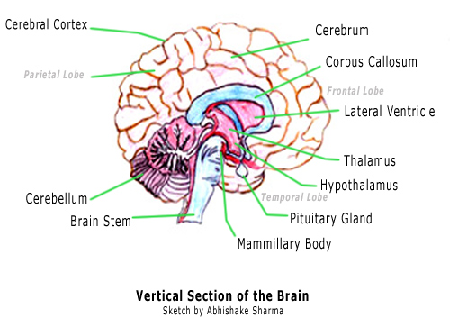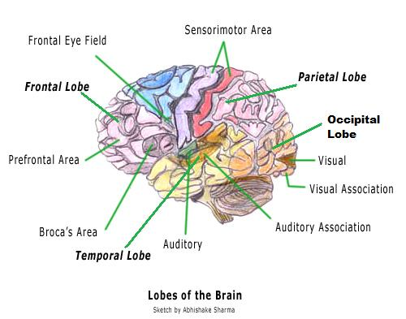Brain regions and their relation with cognitive abilities

Figure 5: Lobes of the Brain

Figure 6: Vertical Section of the Brain

|  |  |
| --- | --- |
| **Brain Regions** | **Functions of Brain Regions** |
| Cerebral Cortex | Learning new information, forming thoughts, making decisions, analyzing sensory data and performing memory functions. |
| Frontal Lobe | Concentration, elaboration of thought, judgment, analytical and critical reasoning, inhibition. Thus involved in personality development and emotional traits. |
| Parietal Lobe | Processing of sensory input, sensory discrimination. Helps in body orientation. |
| Occipital Lobe | Primary visual reception area and primary visual association area. |
| Temporal Lobe | Expressed behavior, receptive speech and information retrieval. |
| Thalamus | Act as the relay station of sensory signals and provide the brain information on what is happening outside the body. |
| Hypothalamus | Collects information from each of the senses excluding smell and distributes the information to the cerebral cortex |
| Amygdala | Controls memory and human emotions |
| Hippocampus | Involved in the recognition and processing of spatial relationships. |

Modern psychological theory views cognition as multidimensional while acknowledging that the many different abilities are themselves positively correlated. This positive correlation across abilities has led to accept the reality of a general cognitive ability. Despite the large role played by genetic and physiological differences in explaining adult variance in cognitive ability, there is considerable evidence that intelligence is highly malleable and the life outcomes influenced by intelligence.

1. Neural Plasticity

Neural plasticity does not mean that our brains are made of plastic. Plasticity or neuroplasticity is the lifelong ability of the brain to reorganize neural pathways basedon new experiences. As we learn, we acquire new knowledge and skills through instructions or experience. In order to learn or memorize a factor or skill, there must be persistent functional changes in the brain that represent the new knowledge.

We can imagine a film of a camera to illustrate the concept of plasticity. Pretend that the film represents your brain. Now use that imaginary camera to take a picture ofa bird. When a picture is taken, the film is exposed to new information, which isthe image of the bird. In order for the image to be retained, film must react to the light and change to record the image of the bird. Similarly, I n order for new knowledge to be retained in memory, changes in the brain representing the new knowledge must occur.

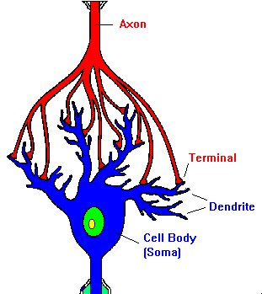

Figure 7: Neural Connection

* Plasticity of Learning and Memory

It was once believed that as we aged, the brains networks became fixed and unchangeable. In recent years brain research has revealed that the brain never stops changingand adjusting. Learning, as defined by Tortora and Grabowski (1996), is the ability to acquire newknowledge or skills through instruction or experience. Memory is the process by which that knowledge is retained over time. The capacity of the brain to changewith learning is plasticity. According to Durbach (2000), there appears to be at leasttwo types of modifications that occur in the brain with learning:

1. A change in the internal structure of the neurons, the most notable being in the area of synapses.
2. An increase in the number of synapses between neurons.

* Neural Plasticity related studies suggest us that we can improve our brain. And for the improvement of our brain we need to exercise our brain and keep it fit. And thereby, games can play a very important role.

1. 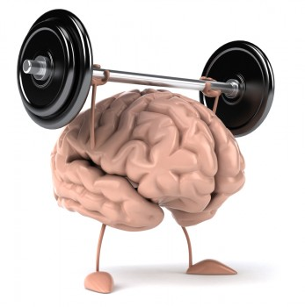What is Brain Fitness?

Brain fitness means that your brain can change—for better or worse—throughout life, and there are measures you can take to ensure your brain's "fitness." A fit brain is evident by its ability to assimilate information, remember information, concentrate, reason clearly, make decisions, and comprehend situations and relationships. Whereas before scientists thought these cognitive abilities naturally declined with age, they now hypothesize that the brain can be maintained and improved by "exercise." Such exercise includes mental stimulation, physical exercise, good nutrition, stress management, and sleep. A fit brain reduces the risk of age-related dementia, Alzheimer's, and other cognitive diseases.

* **How do we Measure Brain Fitness?**

1. Neurogenesis. Neurogenesis is the creation of new neurons, and an increase in synapse and dendrite connections between the neurons, called dendritic sprouting. Neurogenesis can be measured at the cellular level. The more active a brain is, the more connections the brain develops.   
  
2. Cognitive Ability Evaluation. Brain fitness can be determined by testing an individual's memory, attention, concentration, functions, decision-making, and mental capabilities.

* **Using Games for Brain Fitness**

A large number of studies (some in very high-impact journals) are suggesting that regular video game players have demonstrated a number of cognitive benefits relative to non-video game players. Bavelier, Levi, Dan, Hensch have published a paper in the journal of neuroscience on removing the brakes on adult brain plasticity. Bavelier again with Green and Hubert-Wallander has published another paper, which suggests that action video games stretch the limits of visual attention.

* After studying research results on Neural Plasticity and Brain fitness, I felt to make my own games, which will also improve human cognitive skills. And as now a days iPhone and iPad are very popular, I have chosen iOS devices as my platform so that I can reach a lot of people with my games and study the relation between cognitive skills and brain games. And it will be very satisfying for me if my games can help relieve patients who are suffering from age-related dementia, Alzheimer’s, and other cognitive diseases.

1. i0S platform and device description

Before explaining about my game development experience, I will briefly describe about iOS devices. Everyone knows that iOS is now the most advanced mobile platform in theworld. I have used the iOS Software Development Kit and Xcode to develop my applications that have positive impacts onhuman cognitive abilities. iOS is very compact and efficient, and perfectly capable oftaking the maximum advantage of the iPad, iPhone and iPod touch hardware.

* + Cocoa Touch

**Cocoa Touch** is a UI framework for building software programs to run on the [iPhone](http://en.wikipedia.org/wiki/IPhone), [iPod Touch](http://en.wikipedia.org/wiki/IPod_Touch), and [iPad](http://en.wikipedia.org/wiki/IPad) from [Apple Inc.](http://en.wikipedia.org/wiki/Apple_Inc.)Cocoa Touch provides an [abstraction layer](http://en.wikipedia.org/wiki/Abstraction_layer) of [iOS](http://en.wikipedia.org/wiki/IOS_(Apple)), the [operating system](http://en.wikipedia.org/wiki/Operating_system) for the iPhone, iPod Touch, and iPad. Cocoa Touch is based on the [Mac OS X](http://en.wikipedia.org/wiki/Mac_OS_X) [Cocoa API](http://en.wikipedia.org/wiki/Cocoa_(API)) toolset and, like it, is primarily written in the [Objective-C](http://en.wikipedia.org/wiki/Objective-C) language. Cocoa Touch allows the use of hardware and features that are not found inMac OS X computers and are thus unique to the iOS range of devices. Just like, Cocoa Touch follows a [Model-View-Controller](http://en.wikipedia.org/wiki/Model-View-Controller) (MVC) software architecture.

* + iOS Hardware Differences

|  |  |  |  |  |
| --- | --- | --- | --- | --- |
| Device | Processor (MHz) | Graphics | Resolution | Memory (RAM) |
| 1G Devices | 412 | PowerVR MBX | 480×320 | 128 |
| iPhone 3G | 412 | PowerVR MBX | 480×320 | 128 |
| iPod Touch | 532 | PowerVR MBX | 480×320 | 128 |
| 3G Devices | 600 | PowerVR SGX535 | 480×320 | 256 |
| iPad/iPad2 | 1000 | PowerVR SGX535 | 1024×768 | 256 |
| iPhone 4/4S | 1000 | Unknown | 960×640 | 512 |

In this research I have used iPhone 3G and iPad2 as during the game development. The software development kit Xcode has a feature called iOS deployment target. By using this feature it is possible to manage source codes so that the games will run on any iOS device. I set iOS deployment target as iOS 4.3 for my first game SnowMath and i0S 5 for other games.

1. Game Development

In this research, SnowMath, Parallel Brain, Tune Your Vision, Matrix, Wide Eye have been developed for both iPhone and iPad. I will try to give elaborate explanation for SnowMath, Tune Your Vision and Parallel Brain and will briefly mention about Matrix and Wide Eye.

* 1. Development of SnowMath

SnowMath is my first i0S game and throughout my research I have spent most of my time on the development of SnowMath. SnowMath is designed to have a very user-friendly interface. From the menu to the game scenes, I have tried so much to maintain simplicity.

* + 1. Origin of my Idea of developing SnowMath

I am a big fan of Lumosity Lab that has developed a very popular website called http://www.lumosity.com which offers a very promising brain fitness program and the researchers of Lumosity are highly qualified professionals currently engaged in leading brain researches in the top universities of United States Of America. When I started researching in my 5th year project at the department of Information Engineering at Kagawa NCT, I thought I might study Lumosity researches and develop similar kind of games and study how my games can improve the cognitive skills of my future game users. SnowMath can be described as a child of the game ‘Rain drop’ which has been developed by Lumosity for improving problem solving skills.

* + 1. Targeted Cognitive Skills

As I love mathematics, I wanted to first focus on cognitive skills that are related with mathematical skills. I studied about the brain regions that work while we solve problems especially mathematical problems. So the following figure will illustrate the cognitive skills “SnowMath” is developed to improve. These skills have been described briefly mentioned before in Section 2.

Figure 8: Cognitive Skills targeted by ‘SnowMath’

* + 1. Frameworks used in SnowMath
    - What is a Framework?

A **framework** is a hierarchical directory that encapsulates shared resources, such as a dynamic shared library, nib files, image files, localized strings, header files, and reference documentation in a single package. Multiple applications can use all of these resources simultaneously. The system loads them into memory as needed and shares the one copy of the resource among all applications whenever possible.

Shared Libraries

Nib Files

Image Files

Image Files

Header Files

Documentation

Figure 9: Illustration of a Framework

* + - Name of the Frameworks used

OpenGL ES

Open AL

Quartz Core

Audio Toolbox

AV Foundation

UI Kit

Foundation

Core Graphics

Quartz Core

Figure 10: Frameworks used in SnowMath

I have mostly used the game development framework called cocos2d for iPhone for the development of this game. Cocos2d is written in Objective-C, which is Apple’s native programming language. At the beginning of the development of SnowMath I have used low-level OpenGL ES code from the OpenGLES framework of the iPhone SDK. It was targeted to deploy only in iPhone. But later when I thought to develop the game also for the iPad that has bigger screen than iPhone, it became tougher to change my source codes for iPad in low-level OpenGL ES code. So from then I started studying about cocos2d and then SnowMath was programmed in cocos2d.

* + 1. Game Scenes

SnowMath is designed with Cocos2d game concepts as I mentioned earlier. Cocos2d makes good use of the Singleton design patter. A singleton is a regular class that is instantiated only once during the lifetime of the application and in SnowMath I have used a lot of Singletons. There are a number of game scenes in SnowMath. Each scene has a mother node and every mother node has several child nodes. The figure below will show the game scenes of SnowMath.

Scene 1

Init

MultiLayer

Scene

Scene 2

Logo

Scene

Scene 3

Multi

Layer

Scene

Scene 2

Menu

Scene

Cross Fade

Transition

Scene 4

Snow

Math

Renderer

Scene 5

MY

EAGL

View

App

Delegate

Root

View

Controller

Controllers

Fade Transition

Figure 11: Game Scenes and their controllers

Above all the scene there is the App Delegate. And the Root View Controller has the responsibility to manage the game view. Inside the App Delegate the root view controller and glView is being allocated, then the animation interval is set to 1/60 and finally call the initMultiLayerScene and the game menu is displayed.

* + - 1. Scene Descriptions

1. InitMultiLayer Scene

This is the first scene that is launched by the App Delegate when iPhone or iPad user first presses the SnowMath icon in the device’s home screen. This scene adds the Logo layer as its child and initiates the logo scene.

1. Logo Scene

This is the Logo scene where the Logo is shown at first. The following figure

is the snapshot of my Logo.

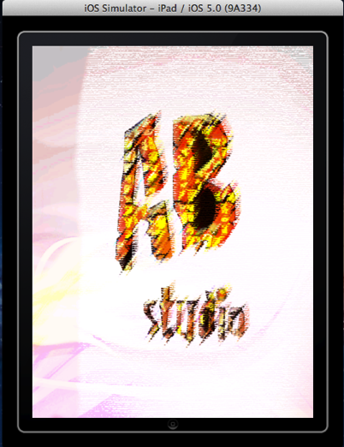



Figure 12: Logo Scene in iPad and iPhone

1. Menu Scene

Game menu is shown in the Menu Scene. At present there are two buttons or options in the menu .The first one is the Play button from where the SnowMath game can launch in different modes. Another button is the help button that will help user to know about the game details and how to play.

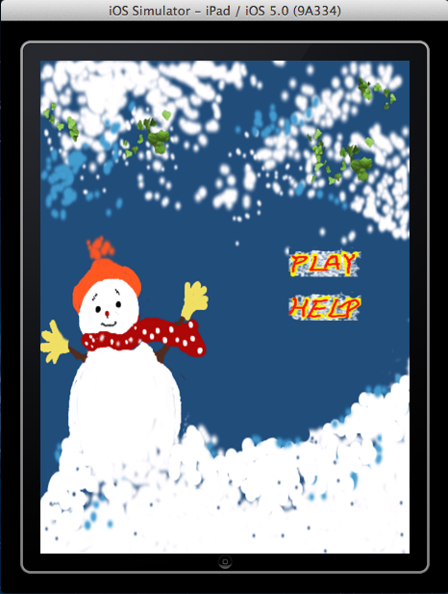

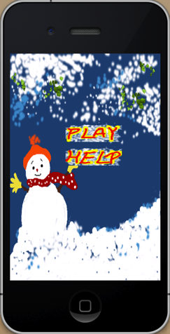

Figure 13: Menu Scene in iPad and iPhone

1. MultiLayer Scene

This is a mother scene, which has two child scenes described below.

1. 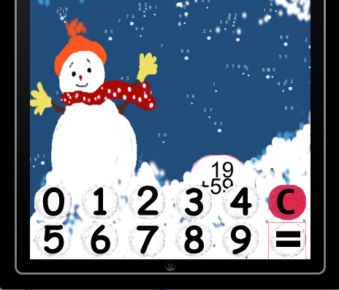MYEAGLView

Figure 14: Customized user input in MYEAGLView

Actually MYEAGLView scene is running over SnowMathRenderer scene where most of the variables and methods are declared. I have created this scene to implement a user input method. Both iPhone and iPad has its own prebuilt keyboard to take user input. I should mention that in SnowMath users are asked to solve the arithmetic equations and they need an input method. I didn’t want to use the device keyboard as it will destroy the beauty of the snow background and so developed my custom input system .You can see the number buttons from 0 to 1 and two additional buttons, one is C for cancelling and another is the equal button for final input, near the bottom line in the image shown in figure 11.

1. SnowMathRenderer

SnowMathRenderer is the principal scene of SnowMath. Most of the variables, classes are declared and being changed during runtime from this class. In this objective C class firstly the background has been created.

Background continues changing using schedule methods of NSTimer. As iPhone and iPad has different screen size, the position of the snowballs, user interface buttons needed to be modified. For this reason, a cocos2d singleton shared Director has been called to get width and height of the screen in this renderer class. To create snowfall, I have first written a class called Snowball. Snowball class is written in C++ language. But here I should mention that C or C++ codes could also be used in objective C language changing the file extension name to ‘.mm’. Arc4Random function is used a lot of time for randomizing numbers which have been used in positioning the balls and timer scheduling.

The following flow diagram will show how the game continues.

Background Initialization

Background Change

Game Life

Start

Snowfall Initialization

Snowfall Change

Randomization,

Numbers & Problem

Generation

Ball Initialization

Machine Learning

& Problem Difficulty

Estimation

User Inputput

Time & Score

Counting

Game Structure

End

Figure 15: Customized user input in MYEAGLView

* + - SnowBall Class

SnowBall class is used for creating snowballs, which are later used for continuous snowfall, and main snowball with each problem.



Figure 16: SnowBall

Each ball has following characteristics:

1. X coordinate
2. Y coordinate
3. Angle of movement
4. Size
5. Speed
6. Turn angle
7. Texture
8. Numbers

x

y

Angle

Turn

Angle

Random

Size



Texture

Figure 17: Snowball Characteristics

* + - 1. Machine Learning Algorithm

I have used machine-learning algorithms in SnowMath. Every individual has differences in their abilities. So algorithms should be applied according to the player’s capability so that players can feel that the machine, in this case the iPod or iPhone, is intelligent.

In SnowMath the program is taking scores from the players and counting their mistakes. It has been programmed to give players a different patterns of problems and find out any pattern in the mistakes of the players. It can create dynamic changes in its patterns while interacting with the players. In fact, it follows a Lazy learning process for as it depends on how many times the player is playing SnowMath. And often it takes time to find patterns. But after getting patterns for that particular user, the program makes its decision tree to create further problems. It also can reason case by case .It will create different difficulty modes after case based reasoning. Overall in SnowMath, I have written codes in such a way that the program can be supervised by the information it gets from the player while playing and previous information it stored before in the database.

Figure 18: Supervised Learning in Machine Learning Algorithm

* 1. Development of Parallel Brain

Parallel Brain is the second game I have developed in my research. It will increase

our efficiency in parallel brain activity.

* + 1. Origin of my Idea of developing Parallel Brain

I think that we, the modern people, are smarter than our ancestors. In our present age, we have to cope with a variety of things at the same time. Modern life has certainly become very convenient but these conveniences made our life complex. We are supposed to develop our ability of parallel thinking, enhance skills to manage variations and carefully examine to solve life problems. And we know, not everyone is capable enough of doing all these efficiently. Some of us face attention deficit disorders and are very weak in parallel brain activities. As we grow older, we loose our power of parallel thinking. Modern scientists recommend that we should always exercise our brain to keep it active. And parallel brain is my effort to develop an environment to do so.

* + 1. Targeted Cognitive Skills

Figure 19: Cognitive skills targeted by “Parallel Brain”

* + 1. Game Development Stages

The development of Parallel Brain can be divided into three stages. The figure 15 is showing the stages.

Figure 20: Three stages of “Parallel Brain” development

At first I have designed the main game screen using Xcode’s new storyboard tool. In the next page, I will describe about storyboard and the way I designed the game.

In parallel Brain, users will press either left or right green button depending on

the answer they think to be the right one. If the answer is right they will see the

correct mark along with an affirmative sound or in the case of a wrong answer they will

a cross mark with a harsh buzz meaning negative.

* Different modes of Parallel Brain

Figure 21: Question modes of Parallel Brain

There are different modes by which questions will be given. Players will be asked

constantly to determine which box has the capital or small letter of English Alphabet or which box got the Number or Vowel or which box got the Hiragana or Katakana. They will be compelled to change their mind frequently. When they are asked about numbers, the region of the brain, which operates mathematics, will be active. But at that moment, they will be asked about letters or colors or they will be asked to find about the size.

Thus they have to perform parallel brain activities while playing this game that will enhance their ability of dealing multiple things together.

* What is a Storyboard?

Storyboards are graphic organizers in the form of illustrations or images displayed in sequence for the purpose of pre-visualizing a motion picture, animation, motion graphic or interactive media sequence. Storyboards are a new feature for iOS developers introduced with Xcode 4.2 and iOS 5 SDK.

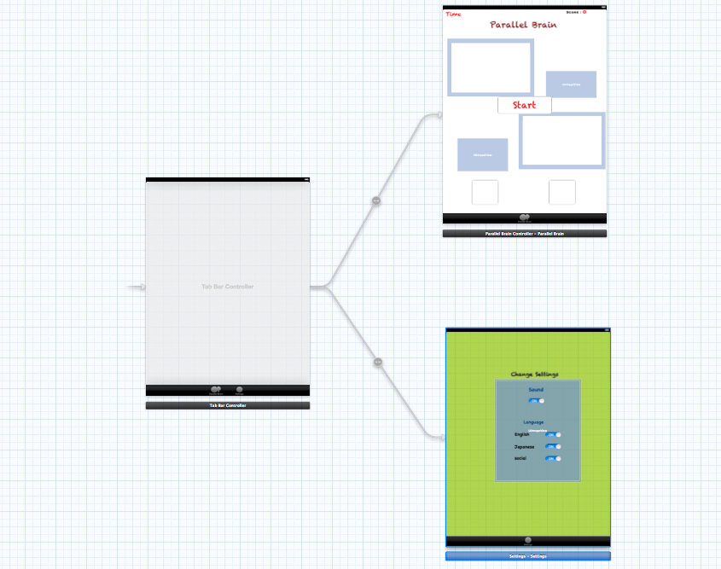

Figure 22: Storyboard and its connections

I have used Storyboard for designing Parallel brain as well as Tune Your Vision that I will describe later.

* Game Screen of Parallel Brain

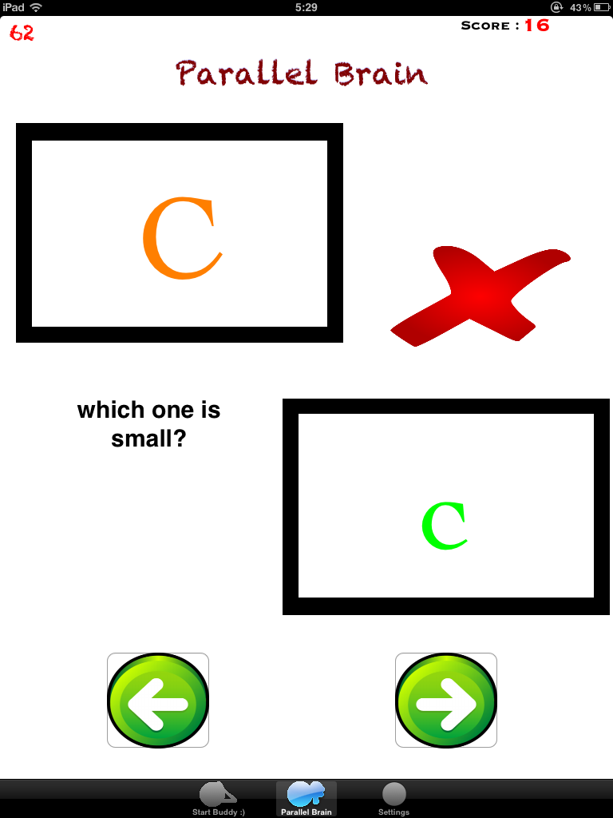

Figure 23: Snapshot of Parallel Brain

In the upper left corner, I have put the time label. I have set 120 seconds as a default value for the time label but player can change the value from settings tab. In the upper right corner the score will be shown. Player can also change game modes manually from settings.

* 1. Development of Tune Ur Vision

Tune Ur Vision has been developed to improve vision skills and speed. We have to see a lot of things everywhere around us. And sometimes we don’t notice a number of things. It always gets tough when we are to search something within a time constraint. Players who will practice with Tune Ur Vision are likely to improve their visual attention as well as auditory attention. Below I am showing the targeted cognitive skills in a diagram.

* + 1. Targeted Cognitive Skills

Figure 24: Cognitive skills targeted by “Tune Ur Vision”

* + 1. Game Development Stages
* Game Screen of Parallel Brain



Figure 25: Snapshot of Tune Ur Vision

In Tune Ur Vision I am mostly using pictures. There are 3 options for pictures.

About 20 images are being used so that player needs to memorize a lot of information. And different sound effects are also included. Players have to memorize those sounds to make their answers correct. The speed of appearance will change with the course of time. So players have to give much concentration. The program with its machine learning algorithm will try to find out players’ weaknesses. and give more tough patterns.

* 1. Development of Matrix

In matrix I have used square blocks. Object will be placed on the square blocks. Objects are of different colors and shapes. The size of the square matrix will also differ depending on the stage of the game. Players have to remember following information:

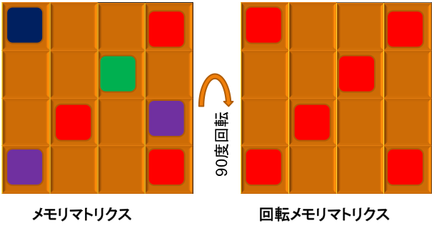

Figure 26: Example of Matrix

The game will get tougher when the full matrix will be rotated. The players have to mentally rotate the matrix to find out the right position as well as the colored blocks. Sometimes they will be asked to find out only red, green or blue blocks. Gradually the game will be harder and players have to use their brain power more that will consequently improve their abilities.

* 1. Development of Wide Eye

Wide Eye has not yet implemented on the device. But the main algorithms have been prepared and source codes have also been written. Wide eye is also for visual perception. It will enhance spatial performance and increase attention of the players.

1. Brain Performance index (BPI)

Brain Performance Index (BPI) is a measure of brain performance in a given cognitive function. I have used BPI to track player’s performance, and compare their ability in one cognitive area to another.

* **How is BPI calculated?**

The BPI scales are based on an analysis of the real game results, e.g. scores of the players in SnowMath, Parallel Brain, Tune Ur Vision, Matrix, and Wide Eye. I used these average weekly scores to create a distribution of scores for each activity so we know how an individual score stacks up to all others. I then evaluate a player’s game scores and use a proprietary algorithm to derive your BPI. Each time a player plays, BPI gets updated.

* **Equation**

**BPI =**

**0** 50 100

**SnowMath**

Tune Ur Vision

Parallel Brain

**平均**

Figure 27: Cross Bar example graph of BPI

1. Game Development Tools

Here is a list of the hardware and software I have used :

* Hardware

1. Macbook 2.4 GHz Intel Core 2 Duo
   * + - Memory 4 GB 1067 MHz DDR3
     1. Macbook Pro 2.8 GHx Intel Core i7
        + Memory 4 GB 1333 MHz DDR3
     2. iPhone 3G
     3. iPad 2

* Operating System

1. Mac OSX Snow Leopard (Macbook)
2. Mac OSX Lion 10.7.3 (Macbook Pro)
3. iOS 4.3 (iPhone)
4. iOS 5.0 (iPad)

* Software

1. Xcode 4.3
2. Interface Builder
3. Adobe Photoshop
4. Adobe Illustrator
5. Adobe flash
6. Zwoptex
7. Texture Packer
8. Paint Brush
9. Conclusion

Throughout the research, I have a learnt a lot of things about brain and neuroscience. Brain’s performance is very important for everyone. We should always keep exercising our brains. I hope games developed in this research will help to enhance the player’s cognitive abilities. Regularity is also very important. Even in playing games, a player should regularly exercise with games.

We should mind that only games can not improve our cognitive skills. There are other factors we have to consider.

References

[1] Jonathan Zdziarski: iPhone SDK Application Development Guide 2009

[2] 赤松正行: iPhone SDKの教科書　Cocoa Touch プログラミング,最初の一歩 2009

[3] Steffen Itterheim: Learn iPhone and iPad cocos2d Game Development 2010

[4] 横江宗太: OpenGLで作るiPhone　SDKゲームプログラミング 2009

[5]　Chandramallika Basak, Walter R. Boot,　Michelle W. Voss, and Arthur F. Krame Can Training in a Real-Time Strategy Video Game Attenuate Cogni tive Decline in Older Adults?

[6] http://en.wikibooks.org/wiki/Cognitive_Psychology_and_Cognitive_Neuroscience

[7] Dye, M.W.G., Green, C.S., Bavelier, D. (2009). Increasing speed of processing with action video games. Current Directions in Psychological Science, 18(6), 321-326.